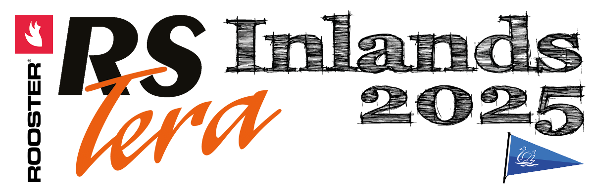

PROTEST TIME LIMIT

Date | Saturday, 25 April 2026

Class / Fleet | Protest time limit
Pro | 17.02
Sport | 17.13

Time posted: 16:39

